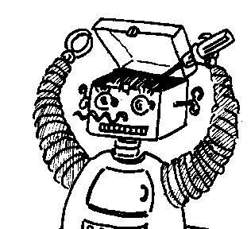
Maryland
Metacognition Seminar
THE COGNITIVE DIALOGUE:
A NEW ARCHITECTURE FOR COGNITION
Yiannis Aloimonos
Department of Computer Science, University of Maryland
Friday May the 4th at 12 noon, Room 3258, A. V. Williams Bldg.

I present a new framework for the design of cognitive systems, i.e. systems with perception that reason, act appropriately and communicate effectively with humans. The integration of the different cognitive competences is achieved through a dialogue between the vision system, the sound system, the motor system, and the language/reasoning system. The Visual Executive (VE) is (the set of processes) responsible for processing the images and accessing memory, the Language Executive (LE) is in charge of language and the intentional system, and so on. The system functions by having the LE ask the other Executives specific questions, receive answers, ask new questions, and so on, until the problem is solved, in a way reminiscent to the 20 question game. For example, if the task is to produce a semantic description of a scene that may contain humans engaged in some behavior, the LE can ask the VE a number of questions, such as: is there <noun?> in the scene? Where is it? What is next to <noun>? Where did the agent that performed <action> go afterwards? What is in the hand of this person? Is this person moving fast or slow? Is <noun1?> bigger than <noun2?>? and so on.
For that dialogue however to take place, that is for the VE to provide answers and the LE to pose questions, we need a number of tools that relate vision and language (visual and language processes). We also need systematic ways for selecting the next question. The talk will describe those processes in detail and show experimental results from the application of the theory to (a) humanoid robots that perform actions given a command in language (from language to action), and (b) to cognitive systems that observe human manipulatory actions (actions involving objects and tools) and describe them in language. Both applications utilize the metacognitive loop.

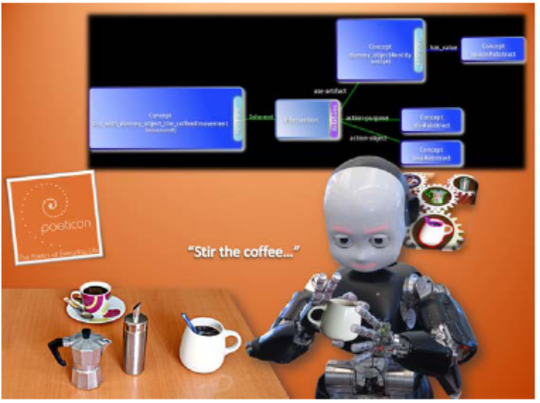
Bio Yiannis Aloimonos is Professor of Computational Vision in the Department of Computer Science at the University of Maryland and the Director of the Computer Vision Laboratory in the Institute for Advanced Computer Studies. He studied Mathematics in Athens, Greece and Computer Science in Rochester, NY. He is interested in the integration of vision, action and cognition. The research described in the talk is supported by NSF, NIH and the European Union under the Cognitive Systems Program (project POETICON).

